Problem 1.

The Number of Clusters are free to be decided but good practice is to use Elbow method or Silhouette method to find optimal number. From 4 to 5 there is no dramatically change so in both cases so I choose to have 4 cluster. I divided my customers into 4 groups. Surprisingly most of people were clustered in one group meaning we do not have very different customers. 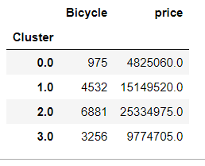

Here you can see overall contribution of each cluster to total revenue of the company. as we see clusters 1 and 2 are the customers who are most loyal and from who company gets the biggest part of total revenue, Interest part is there is only one person in cluster 2. Besides here you can see bicycles sold most other analysis are in python file.

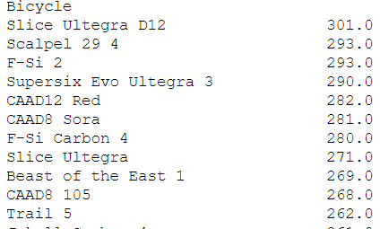

Problem 2.

|  |  |  |  |  |
| --- | --- | --- | --- | --- |
|  | **Flavor** | **Packaging** | **Light** | **Organic** |
| Relative Importance | 60% | 10% | 19% | 12% |
| Highest Utility Level | **Vanilla** | **Cone** | **No low fat** | **Organic** |

Problem3.

I agree with the statement due to the fact it satisfy requirements of the management tool NPS. NPS score is difference between percent of **promoters** and **detractors** and if number is   positive (i.e., higher than zero) is felt to be good, and an NPS of +50 it is considered excellent. (Wikipedia)

In our case 40% percent of our customers are **Promoters**, 20% **Detractors** and the rest is **Neutrals** , so score is 20 which is good and we can conclude that customers of Branch A. In contrast to it NPS score is 1 for Branch 2 where we cannot say that they have loyal customers.

Problem 4.

1.Correlation refers to the association between two variables.

2. Conjoint analysis identify important attributes that influence consumer choice.